STATEMENT OF QUALIFICATIONS 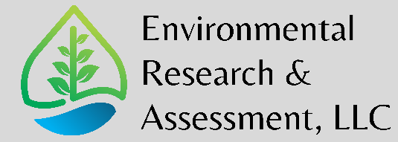

Oregon Emerging Small Business, Certification #: 14623

Environmental Research & Assessment, LLC (ERA) provides a full range of environmental consulting services to public and private clientele, including the industrial/commercial sector, schools, municipalities, government agencies, and the financial/development community.

COMPANY OVERVIEW

Founded and headquartered in Eugene, OR, ERA provides public and private sector clients with high quality, responsive, and cost-effective service for their environmental consulting and engineering needs. ERA’s team of qualified Geologists, Industrial Hygienists, Environmental Scientists, and Safety Professionals possess the requisite knowledge, training, experience, and responsiveness to provide clients with the environmental consulting services they require for successful completion of their projects. ERA is proud to be certified as an Oregon Emerging Small Business (ESB) (Certification #: 14623).

DEMONSTRATED EXPERIENCE

ERA has established a highly respected reputation for expertise in the following areas: Phase I and II environmental site assessments; soil and groundwater investigations and remediation; regulatory compliance and permitting; hazardous materials consulting (including asbestos, lead, and other hazardous materials testing and abatement oversight); mold and indoor air quality investigations; industrial hygiene and safety; and hazardous waste management.

A PRACTICAL APPROACH

Founded on a commitment to delivering comprehensive solutions that address the specific technical, regulatory, financial, and operational needs of each client, ERA embraces a practical approach that emphasizes efficiency of design, quality of work, and on-time performance. Quality assurance/quality control underlies every aspect of ERA’s project work, supporting a corporate policy of individual accountability with appropriate oversight. ERA’s services are firmly rooted in sound project management principles that combine technical excellence with cost-efficiency and responsiveness to each individual client’s needs.

MULTI-DISCIPLINED CAPABILITIES

ERA’s multi-disciplinary staff and network of specialized sub-consultants include environmental engineers, scientists, industrial hygienists, geologists and hydrogeologists, safety professionals, construction managers, biologists, regulatory specialists, and risk assessors.

SERVICES

Environmental Site Assessment, Investigation and Remediation
ERA conducts site assessments to evaluate the potential environmental liabilities posed by acquiring, leasing or financing real estate. Before clients complete a transaction, ERA helps reduce their exposure to environmental and public health-related liabilities by assessing the remedial measures needed to mitigate risks. ERA personnel address site investigation and restoration needs for projects ranging from the cleanup of small spills to the investigation and remediation of major sites. Using a phased approach, ERA tailors each investigation to fit the characteristics of the site, needs of the client, and the anticipated use of the property. For property transfers, ERA helps clients minimize their exposure to liabilities associated with potential or existing contamination. ERA conducts remedial investigations and feasibility studies (RI/FS) on soil, sediment, groundwater, and surface water contaminants including metals, volatile organics, petroleum derivatives, and organic compounds such as PCBs and pesticides. In addition, ERA designs and manages remedial programs and implements operation and maintenance plans.

Regulatory Compliance and Permitting
ERA assists clients in achieving and maintaining compliance with local, state and federal regulations through services that include permitting, facility audits, and regulatory review and interpretation. ERA provides environmental construction monitoring and compliance services, ensuring that all applicable environmental permit applications and/or reports are prepared for clients as required, and that all construction environmental operational requirements and mitigation measures are met by contractors throughout various construction and development projects. ERA prepares construction and operational Storm Water Pollution Prevention Plans (SWPPPs), Urban Stormwater Management Plans (USMPs), and Business Management Plans (BMPs). ERA’s experience includes interfacing with a variety of federal, state and local regulatory agencies, including Oregon Department of Environmental Quality (ODEQ), Oregon Department of Fish and Wildlife (ODFW), U.S. Army Corps of Engineers (USACOE), U.S. Fish and Wildlife Service (USFWS), County Environmental Health Departments, Air Quality Management Districts, Fire Departments and Municipalities.

Industrial Hygiene and Safety
ERA offers comprehensive occupational health and safety services to protect employees and the public from hazards, minimize liability issues, and comply with regulatory requirements and industry standards. Services include industrial hygiene and indoor air quality surveys, compliance program development, health and safety training, worker’s compensation investigations, and facility health and safety audits. ERA provides services to building owners and managers, employers, insurance firms and others in need of indoor air quality assessments, including mold investigations, noise studies, chemical exposure assessments, radon testing, and more. ERA’s technical staff of Certified Industrial Hygienists will identify problem areas and provide the most cost-effective solutions for “Sick Building Syndrome” and other indoor air quality issues. ERA’s experienced staff can also manage and oversee remediation efforts to rehabilitate a contaminated facility. ERA’s Certified Industrial Hygienists have expert witness testimony experience and can provide support to attorneys in preparation for trials.

Asbestos/Lead Assessment and Management
ERA can address every aspect of asbestos-containing materials and lead-based paint assessment and management, from building surveys to the design of an abatement program and ongoing abatement monitoring. In addition, ERA is experienced designing building restorations and serving as a liaison with federal and state regulators. ERA helps clients comply with all applicable regulations, including the General and Construction Industry Asbestos Standard, the National Emission Standard for Hazardous Air Pollutants (NESHAPS), the Asbestos Hazard Emergency Response Act (AHERA), and local air pollution control district rules and regulations.

Storage Tank Management
For underground and above-ground storage tanks containing petroleum products or hazardous materials, ERA has experience with tank installation, testing and monitoring, spill and leak response, free-product recovery, remediation of soil and groundwater, tank removal and closure, and tank management. ERA assists clients with needs ranging from corrosion protection and spill prevention to leak detection, secondary containment, corrective action and closure.

Hazardous Waste Management
ERA manages contaminated waste streams of PCBs, hazardous soil and groundwater under local, state and federal regulations for major clients. ERA provides oversight, permitting, characterization, and handling services.

Project EXPERIENCE

- Eugene Airport (Eugene, Oregon)

- Environmental Services –Three Phase I Environmental Site Assessments (Phase Is) were performed by ERA of facilities at the Eugene Airport related to fueling operations: New Airport Fuel Farm, Old Car Wash/Fueling Facility and the New Car Wash/Fueling Facility. ERA also consulted with the City of Eugene regarding future decommissioning of the Old Car Wash, including underground and aboveground fuel storage tank removal and associated soil and groundwater sampling.

- Umpqua Community College (Roseburg, Oregon)

- Environmental Services –Three Phase I Environmental Site Assessments (Phase I)s were performed by ERA of historic facilities located in Roseburg, OR. UCC has plans to convert these historic facilities (Former JJ Newberry’s, Post Office and Armory) into student housing facilities. These Phase Is were performed under a tight deadline and budget, in which ERA delivered the reports early and stayed within budget.

- Martin Environmental Solution, Inc. (Oregon & Washington)

- Environmental Services –Numerous Phase I Environmental Site Assessment Site Visits (Phase I Site Visits) were performed by ERA of cell tower enclosures located throughout Oregon and Washington. These Phase Is were performed under a tight deadline and budget, in which ERA delivered the reports early and stayed within budget.

- Bellflower Unified School District – Bellflower, California
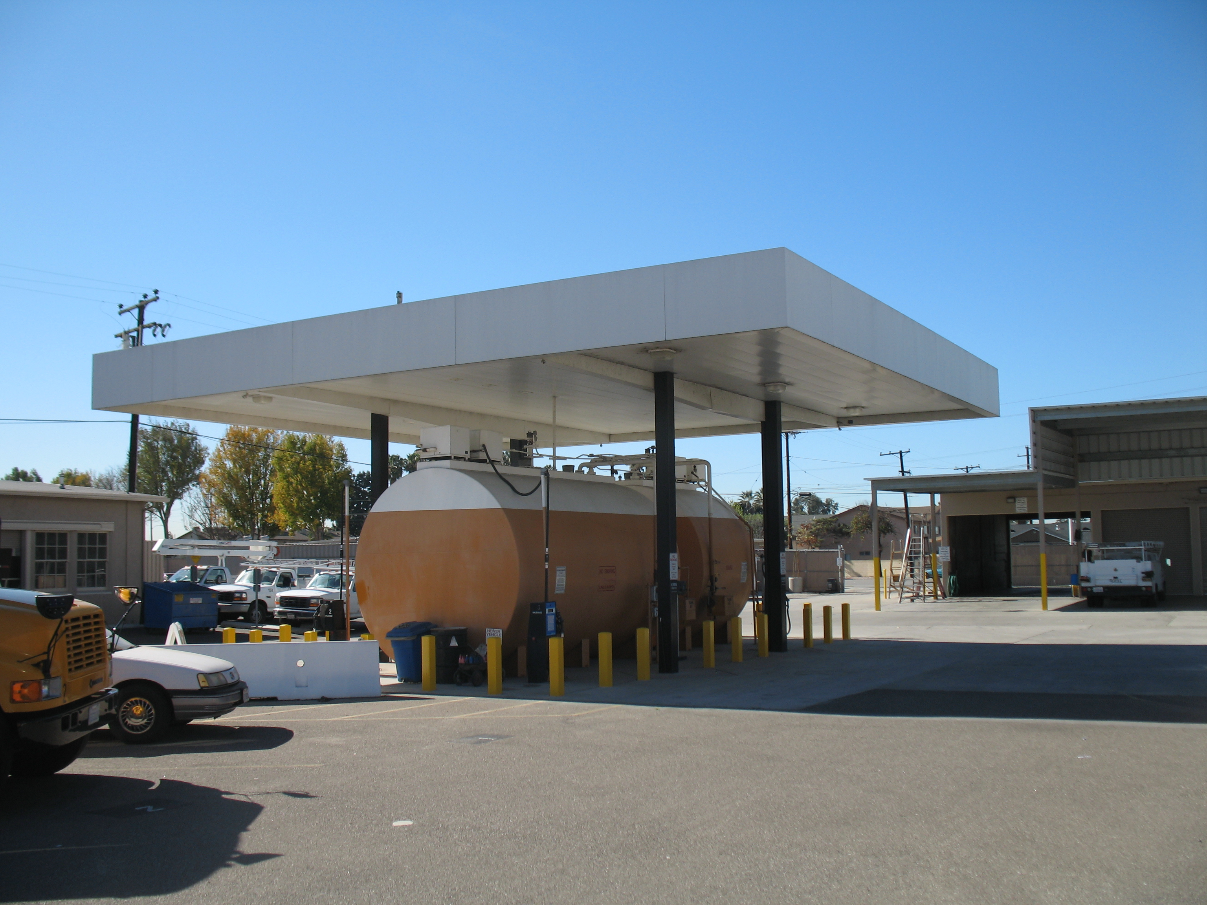
- Environmental Services – ERA personnel provided environmental services to the Bellflower Unified School District at various campuses and District facilities, including Bellflower High School, Mayfair High School, Baxter Elementary School, and the District Maintenance and Transportation Yard. ERA conducted site assessments to evaluate the potential environmental liabilities posed by proposed future expansions of existing campuses. ERA assisted the district in reducing their exposure to environmental-related and public health-related liabilities by assessing the potential remedial measures needed to mitigate risks of the expansions. ERA used a phased approach when conducting the Phase I environmental site assessments, tailoring each investigation to fit the characteristics of the site. ERA conducted a Preliminary Environmental Assessment at a high school campus, per the requirements of the Department of Toxic Substances Control (DTSC), and received DTSC approval in July 2009.

- Los Angeles Trade Technical College – Los Angeles, California

    - Environmental Services – ERA personnel performed sampling around underground storage tanks, drums, clarifiers, transformers and switches for the presence of hazardous materials. ERA performed soil testing before and after removal of all underground tanks and clarifiers to ensure no contamination existed in the surrounding soils. All work was supervised by a Board Registered Geologist. ERA prepared a final closeout report and submitted it to the proper regulatory agency in order for that agency to issue their closure report.

  - California State Polytechnic University, Pomona – Pomona, California

    - Underground Storage Tank/Wind Machine Removal –
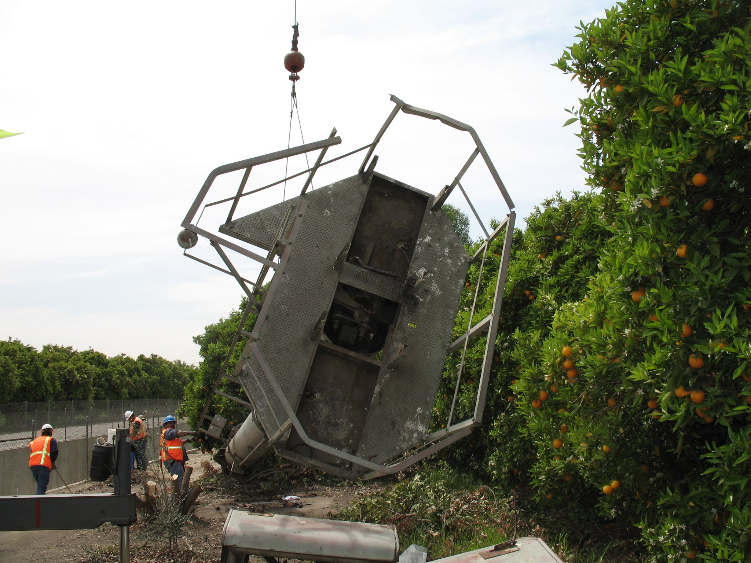
ERA personnel provided environmental services to perform the proper abandonment and disposal of two underground tanks and one wind machine. The underground tanks included a large concrete cylindrical tank and a smaller steel tank. The wind machine was an internal combustion engine-driven wind machine used to stir up the air during times of frost. ERA personnel prepared a work plan that described the required work to allow prospective bidders (contractors) to bid the work, and to provide to agencies for review of procedures. ERA oversaw the removal of the USTs, performed soil sampling, and prepared all necessary closeout reports.

- The Macerich Company – Nationwide

- Industrial Hygiene Services – As part of The Macerich Company’s hazardous materials management program at major shopping centers throughout the United States, ERA personnel provided complete and partial facility assessments to identify lead-based paint, asbestos-containing materials (ACM), and other hazardous materials. Following submission of final assessment reports to identify the quantity, location and condition of these materials and appropriate response actions, ERA personnel developed technical specifications and plans for abatement/remediation. In addition, ERA provides oversight and monitoring of the abatement contractor during all phases of the removal process as well as monitoring for compliance with contract documents and all applicable federal, state and local regulations.
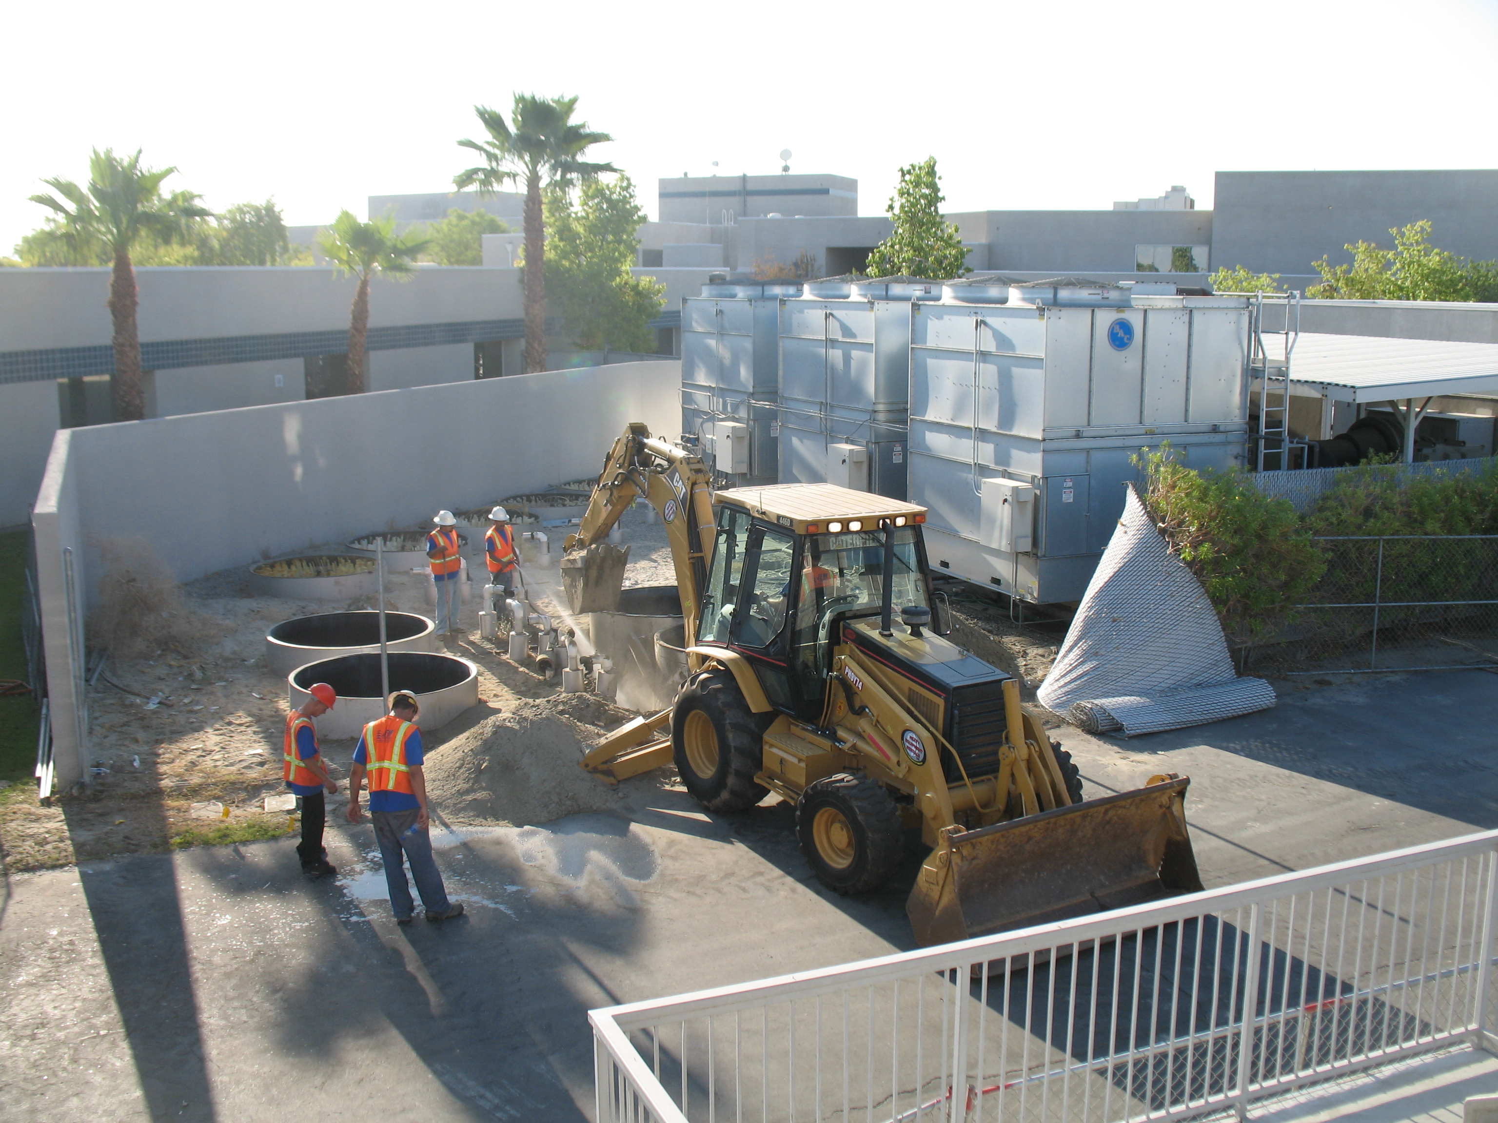
  - Phase I and II Environmental Site Assessment – ERA personnel completed numerous projects to provide Phase I Environmental Site Assessments of large regional shopping malls. Services also typically included asbestos, lead-based paint, lead in water, mold and radon surveys. Phase II projects included the assessment of underground storage tanks, assessment and removal of in-ground hydraulic lifts at former Tire, Battery and Auto (TBA) Centers, soil sampling, excavation of petroleum-impacted soil, and in some cases overseeing the installation of replacement lifts for auto repair facilities located nationwide.
  - Dewatering System – ERA personnel completed a project to retrofit an existing groundwater treatment dewatering system, associated liquid-phase carbon canisters and pumps located in a sub-grade parking garage of a major shopping center. The system treats groundwater contaminated with chlorinated solvents. The treated water is then discharged through a site-specific National Pollution Discharge Elimination System Permit.
  - PCB Disposal – ERA personnel completed a project to sample, characterize and oversee the disposal of 25 large transformers containing polychlorinated biphenyls. The project was completed on an expedited basis to meet a strict construction schedule.
  - Remediation – ERA personnel completed a project to remove an in-ground hydraulic lift, conduct soil sampling, excavate petroleum-impacted soil and oversee the installation of a replacement lift for an auto repair facility.

- Santa Barbara Cottage Hospital – Santa Barbara, California
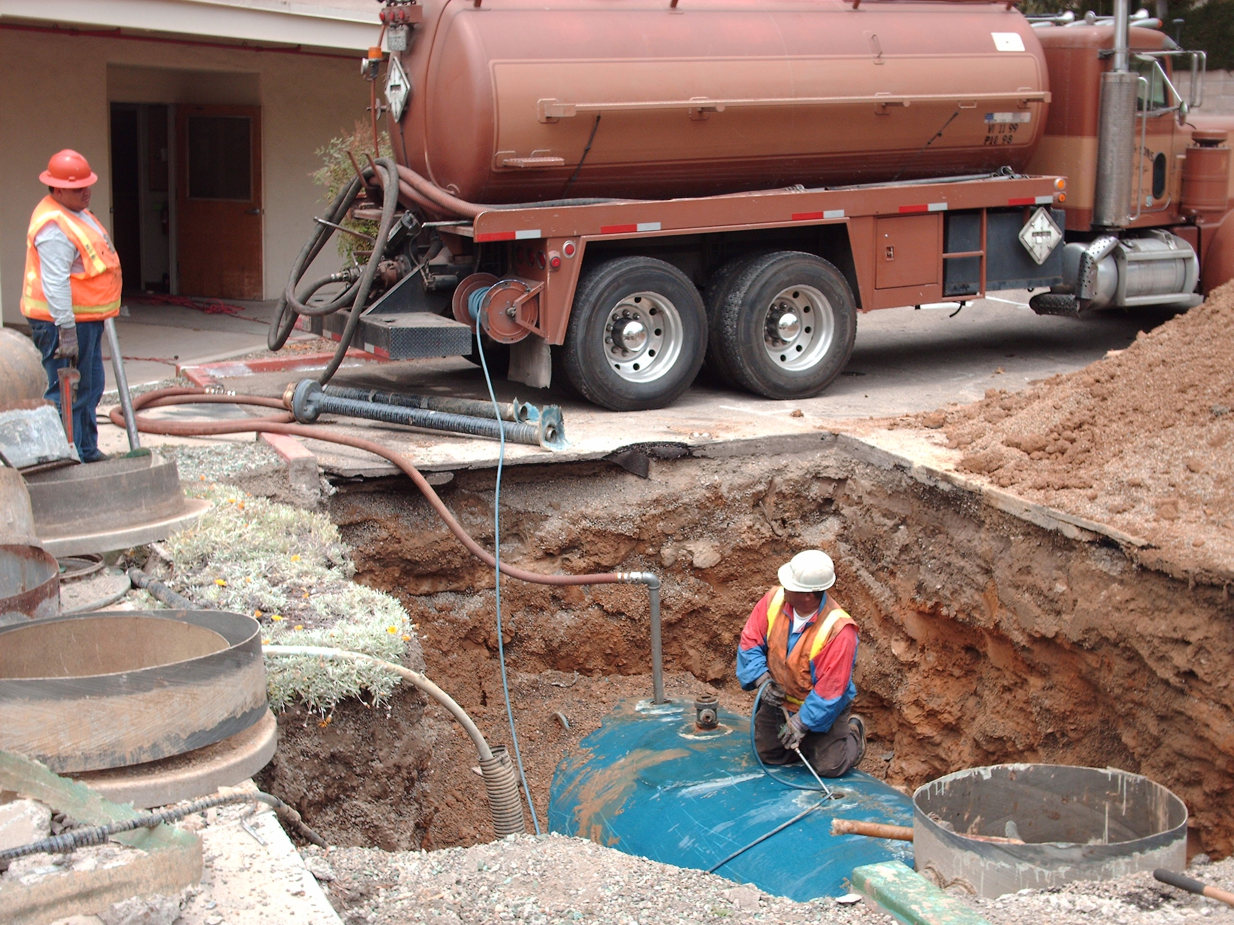
  - Removal of Underground Storage Tanks and Soil Remediation – ERA personnel handled the removal, soil remediation and agency closure of five USTs and associated piping associated with emergency back-up generators at the former Saint Francis Medical Center. This project site was located in a residential neighborhood and was a high-profile project due to concerns from nearby residents. ERA personnel oversaw the removal of the USTs and performed soil sampling and field monitoring. One of the USTs had leaked and ERA oversaw the remediation, prepared a closure report and submitted the closure report to the appropriate oversight agency for final approval.

POINT OF CONTACT

Mr. christopher wells, repa –Principal Scientist/Owner
As founder and Principal Scientist of ERA, Mr. Wells brings more than 35 years of experience to the firm. He has more than two decades of senior-level management experience combined with 15 years of practical experience in environmental consulting. Mr. Wells has a diverse technical background that has proven valuable in managing a professional staff, subconsultants and subcontractors representing various environmental fields. Mr. Wells has managed and performed environmental site assessments and inspections, environmental regulatory research, sampling and assessment of hazardous waste sites, computer database management, lead and asbestos surveys, and lead and asbestos abatement oversight and sampling. Mr. Wells has prepared Phase I environmental site assessments, Phase II subsurface soil and groundwater investigations, asbestos and lead paint assessment reports, remedial action plans, health and safety plans, pollution prevention plans and quality assurance plans. His expertise is utilized for in-house quality assurance during the final review of all projects. Mr. Wells’ vigorous review ensures that the best technical and professional efforts have been used for the successful completion of every project.

